# Test Settings

## ADF-Test

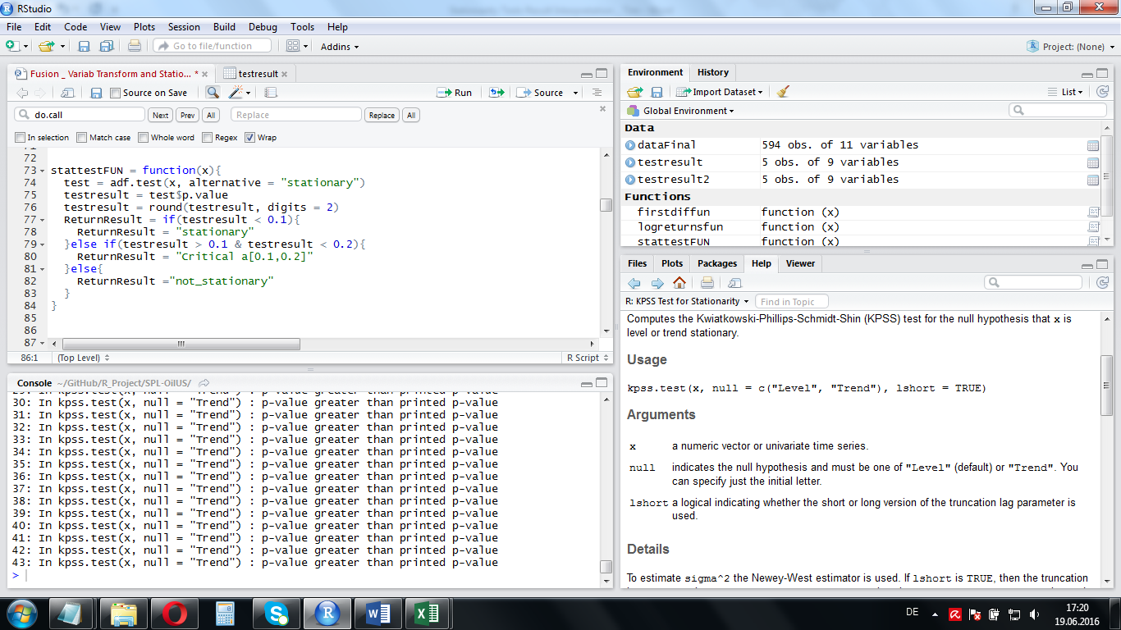H0 : nonstationary-unit root; H1: stationary, i.e. no unit root

Alpha set to 0.1

## KPSS-Test

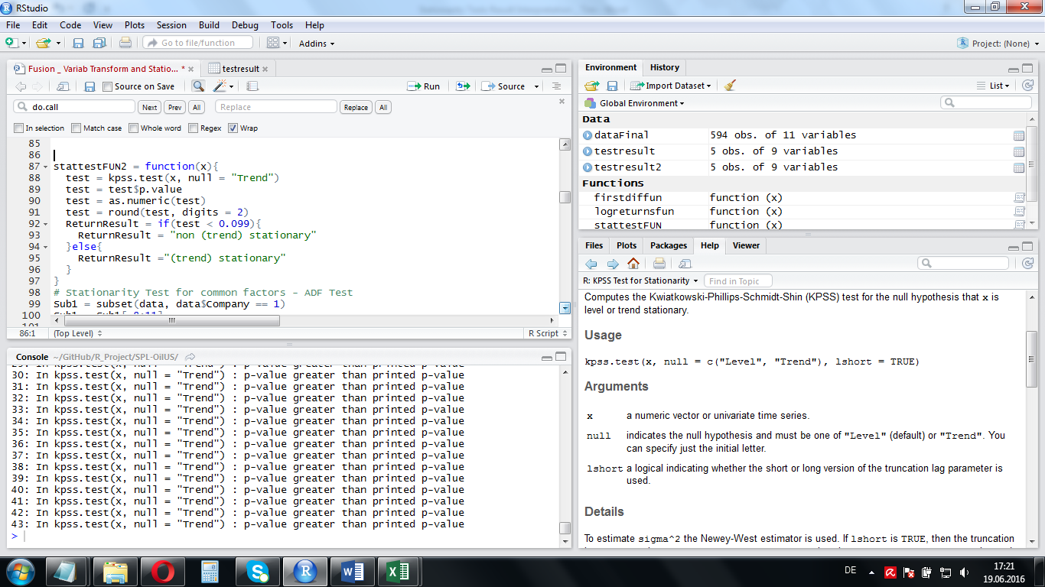H0: trend stationary; H1: not trend stationary

Alpha set to 0.0999 as R prints all p-values above 0.1 as 0.1!

Test, according to me, ‘more risky’ or only to be used in combination with ADF-test because we risk the beta-error of accepting H0 despite it might be wrong. In contrast to the Alpha-error, it is hard or impossible to retrieve the beta error (by testing)

# Stationarity Tests absolute variables

## Common Factors

Clearly, our common factor variables are not stationary given that we take them on their absolute level. A non-stationary transformation is required.



## Company-Specific Factors

### ADF Test results



Almost for all variables for all enterprises exhibit a nonstationary behavior. WE cannot use them in this version for our analysis. Let’s see what the ADF test says

### KPSS Test result



On a 10% level, the KPSS-Test also rejects the H(NULL), that the variables are (trend-) stationary. A transformation is definitely required

## The Panel Unit Root Test – Levin, Lin, Chu (2002)

Levin-Lin-Chu Unit-Root Test (ex. var.: Individual Intercepts and Trend)

data: object

z.x1 = 0.44616, p-value = 0.6555

alternative hypothesis: stationarity

This panel data test is in line with the findings of the indivicual variable tests! Yet this test cannot take cross-sectional dependence into account.

# Transformed variables

## Common Factors

## 

According to these test results, we can be confident that our common factor variables, as they are transformed into quarterly returns, become stationary and thus adequate for a panel data analysis.

## Company-Specific Variables

### ADF-Test



Most company-specific variables end up being stationary.

Those Variables are stationary among all enterprises: A / MCAP, BV(EQ) / MCAP

This variable is stationary for all companies, but company 2: D/E

This variable might (according to the ADF-Test) still be problematic: Net Income. It is non-stationrary for companies: 2, 5, 6 and 7.

Note that these are the companies exhibiting the strongest net income drops into the loss zone between 2013 and 2015! If this triggered the nonstationarity, then it might be that common panel data and time series approaches are not the adequate methods to analyze the consequences of the oil price drop of 2013-2015 on oil companies. This is a shame as the common methods are the ones we can handle. But let’s first wait for the results of the KPSS Tests of the return (first diff) transformations of the variables

### KPSS Test



The KPSS test results indicate, for Alpha = 0,1, that the Null of trend-stationarity for Net Income is rejectes for companies: 2, 5 and 7. This implies that using the first difference of Net Income in our analysis might still be problematic.

## The Panel Unit Root Test – Levin, Lin, Chu (2002)

Levin-Lin-Chu Unit-Root Test (ex. var.: Individual Intercepts and Trend)

data: object

z.x1 = -65.074, p-value < 2.2e-16

alternative hypothesis: stationarity

This test result implies that there is no unit root is present in the transformed data. Note that the test relies on the assumption that the time series are cross-sectionally independent. Still, it can serve as, as the punitroots package is not available for R3.2.4 anymore, as a hint at that our version is usable

# Test results for the timeframe 1996 – 2012

Since we suspected that the non-stationarity of Net Income is mainly driven by the exceptional drops at the end of the observation period, we restricted the evaluation period to1996 – 2012

## Common Factors

|  |  |
| --- | --- |
| ADF | KPSS |
|  |  |

Oil, Gas and Market still stationary according to both tests. EUR/USD non trend stationary according to KPSS.

Yet, we are confident that all those variables are safe to be used in our panel data regressions.

## Company-Specific Factors

### ADF test



When only considering the time frame 1996-2012, according to the ADF-test-criteria, all of our variables are safe to be used. This reinforces our findings from 3.1

### KPSS test 🡪 Similar results



## The Panel Unit Root Test – Levin, Lin, Chu (2002)

Levin-Lin-Chu Unit-Root Test (ex. var.: Individual Intercepts and Trend)

data: object

z.x1 = -54.46, p-value < 2.2e-16

alternative hypothesis: stationarity

This time, the test also indicates stationarity of the panel we use.